**Name:** Shiva Sindhu Poloju

**Id:** 0839961

**Date:** 09/12/2023

**Organizational chart**

1. **Select an organization that you are familiar with and develop a sample organizational chart for that organization. Describe what type of organizational structure is being used. What are the advantages of this structure?  What are the disadvantages?**

I'm familiar with the typical organizational structure of a university or college, which often follows a traditional hierarchical model. Let's create a sample organizational chart for a university to illustrate this structure:

University Organizational Chart:

**Kansas Board of Regents**

**1. Board of Trustees:**

• Chairperson

• Trustees

**2. University President**

• Office of the President

**3. Academic Affairs**

• Provost and Executive Vice President

• Deans of various colleges and schools

• Faculty and academic departments

• Registrar's Office

• Libraries

• Research Centers

**4. Student Affairs**

• Vice President for Student Affairs

• Student Services

• Residence Life

• Career Services

• Student Organizations

**5. Business and Finance**

• Chief Financial Officer (CFO)

• Accounting

• Budget and Financial Planning

• Procurement

• Facilities Management

**6. Human Resources**

• Director of Human Resources

• Recruitment

• Benefits

• Employee Relations

**7. Information Technology**

• Chief Information Officer (CIO)

• IT Services

• Information Security

• Help Desk

**8. Marketing and Communications**

• Chief Marketing Officer (CMO)

• Public Relations

• Marketing Strategy

• Alumni Relations

**9. Development and Fundraising**

• Vice President for Development

• Alumni Giving

• Grants and Fundraising

**10. Legal and Compliance**

• General Counsel

• Compliance Office

**11. Admissions**

• Director of Admissions

• Admissions Officers

**12. International Programs**

• Director of International Programs

• Study Abroad

• International Student Services

**Type of Organizational Structure:**

The organizational structure of this university is a traditional hierarchical structure. It has clear levels of authority and reporting, with each department and office having its own chain of command. The university president serves as the central figure, and various vice presidents and deans oversee specific areas of responsibility.

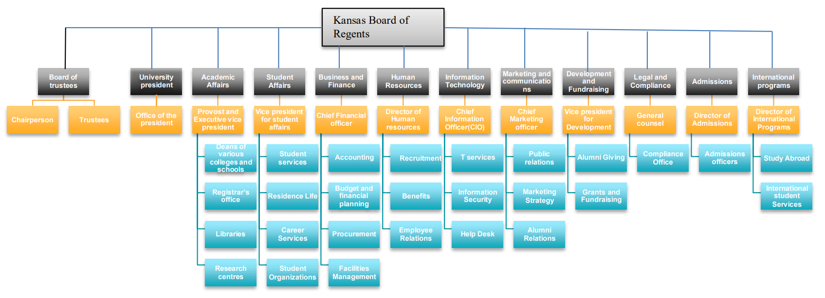

**Advantages of this Structure:**

1. **Clear Chain of Command:** With a hierarchical structure, it’s easy to see who’s in charge of what in each department.

2. **Specialization:** Each department can focus on its specific functions, allowing for specialization and expertise in their respective areas.

3. **Efficiency:** This structure can lead to efficient operations as roles and responsibilities are well-defined.

**Disadvantages of this Structure:**

1. **Bureaucracy:** The hierarchy can result in bureaucracy and slow decision-making processes, as decisions often need to be approved at multiple levels.

2. **Communication Challenges:** Information may not flow smoothly between departments, potentially leading to communication challenges and coordination issues.

3. **Rigidity:** Since this structure is frequently inflexible it might be challenging to quickly adjust to fresh conditions or requirements.

4. **Limited Autonomy:** It's possible that lower-level employees lack the independence to make their own judgements, which can prevent them from being innovative and coming up with fresh ideas.

In conclusion, a hierarchical organisation offers many benefits for specialisation and transparency, but it also has disadvantages for bureaucracy and adaptation.In order to balance these benefits and drawbacks and to satisfy their particular requirements and goals, colleges frequently change their organisational structure.